* Sample Dashboards:
  1. Following dashboard can be used to ‘Track real time migration of IAM users to a Single Sign-On (SSO)’. Here, we used a parameter called “Account” to filter data for a given AWS Account for a specific range of dates.

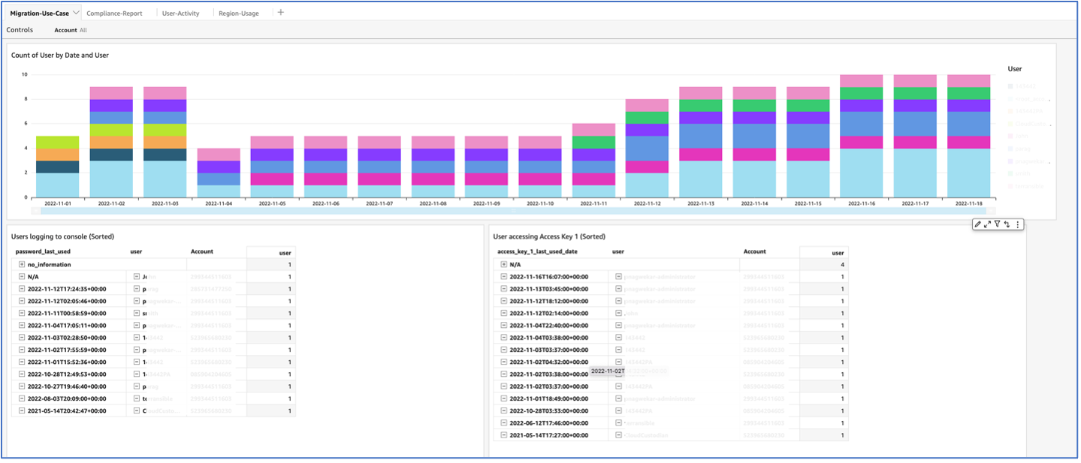

* 1. Following dashboard can be used for ‘Compliance’. Here, we used parameters “Account” and “Date” to filter data.

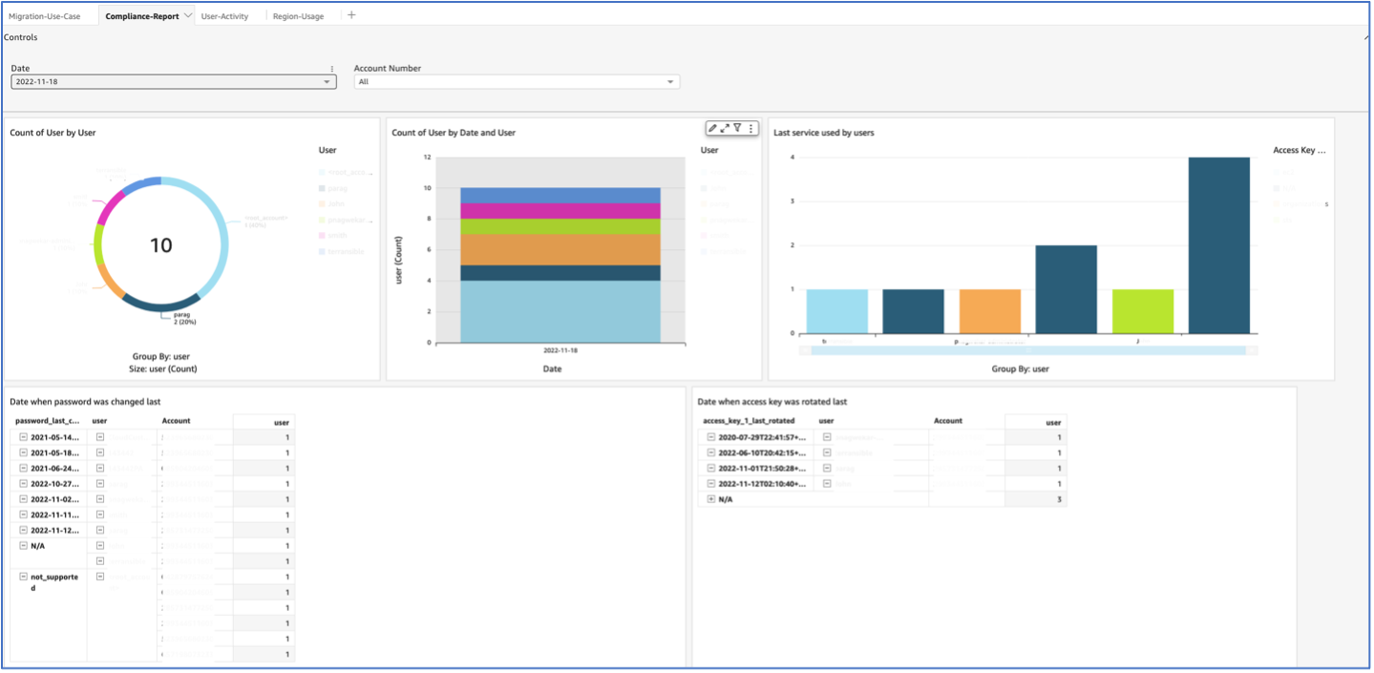

* 1. Following dashboard can be used to ‘identify security incidents related to IAM users’.

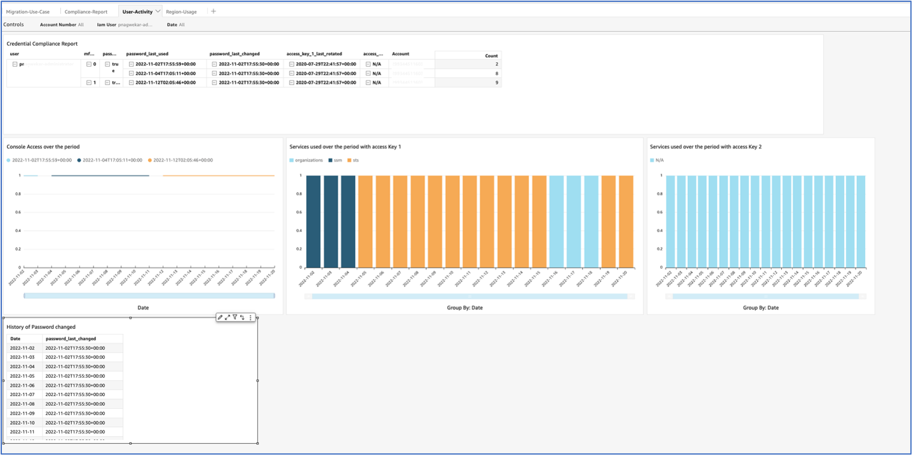

* 1. Following dashboard can be used to ‘track AWS regions accessed by IAM users’.

